Empowering Women’s Safety: Deep Learning Approaches to combat violence
B Ch S N L S Sai Baba^{1*}[0000-0001-5625-3910], Jagana Deepak Kumar¹[0009-0002-2090-8844], J Vinaya Siva Subhash Kotha¹[0009-0000-5024-8942], Javvadi Karthik¹[0009-0006-1139-1723], Jamula Subhashini¹[0009-0007-2896-5313]
¹Vishnu Institute of Technology, Bhimavaram, Andhra Pradesh, India
*sai.ossr524@gmail.com
Abstract: The “Empowering Women’s Safety” project helps in growing the safety concerns for women by sensing real-time threats and their prevention. The system recognizes dangerous situations, such as a lone woman at night or a woman surrounded by men, by continuously monitoring public places through person detection, gender classification, and gesture recognition. It also generates alerts that can be acted at the correct time to prevent incidents from getting worse. The major challenge addressed is the lack of correct safety measures. Although the traditional methods are indeed reactive, in that they react to crimes after they have occurred, the early warning nature of the system limits the opportunity for violence against women. These innovative analytics done by using object detection model YOLOv8 and deep learning techniques augmentation, annotation, can be used to highlight gender distribution at particular sites and identify hotspots where there is a high possibility of threats towards women and send an alert to the control systems to safeguard women. This will benefit women themselves, law enforcement, and city planners in respect to public safety. The project works with the trend of violence against women in cities and advances technology that could detect all forms of threat before it occurred. Maintaining constant observation and monitoring of places leads to proactive solutions. As a result, safer places are created for women, and crimes are eradicated before happening. The system's effectiveness was validated using advanced metrics, demonstrating impressive performance with a mean Average Precision (mAP@50) of 0.864 across all classes. The model showcased particularly high precision for individual categories, such as 0.873 for lone women and 0.94 for women surrounded by men, indicating its robustness in diverse scenarios. These results underscore the model's superior ability to accurately detect threats in real-time, surpassing traditional ap0proaches and setting a new standard for proactive safety measures.
Keywords: Data Augmentation, Annotation, Gender Classification, Alert system, SOS signals, Yolov8, Object Detection.
- Introduction
Women's safety has emerged as a very critical issue these days because of rising crimes against women in almost all major cities [10,11]. Despite all this effort taken on the already present measures, they keep on rising, thus there is an emergent need for more advanced and reliable solutions [1,12]. This project would address this issue by developing a real-time threat detection software that monitors the public space and analyzes possible dangers to women [3]. This system, therefore, is designed to provide continuous surveillance and early warning about unsafe situations [5,20]. It is about immediate alerts and useful data to ensure law enforcement intervention before such incidents rise to dangerous levels [13,14].
The major problem addressed here is effective real-time systems that can both detect immediate threats with a potential for analysis of patterns for prevention of future incidents [9,6]. Most of the existing safety solutions fail because they are merely reactive in nature and do not provide enough detailed information to act upon in real time [16]. Thus, the proposed system with advanced analytics capable of detecting and predicting unsafe situations, provides a unique and necessary tool for women's safety [18]. Strictly focusing on real-time data collection and analysis will make for a deeper impact in preventing crimes against women [17].
The logic behind the project is that continuous observation of public places will enable us to identify danger signs such as a lone woman at night, a woman surrounded by groups of men, or suspicious gestures that may indicate an attack [1]. Our system will be capable of distinguishing between males and females, counting the number of men and women in an area, and using gesture recognition for SOS signals [3,4,20]. More importantly, the system will be able to identify hotspots, which are areas where incidents are likely to occur based on past data and can send alerts to law enforcement or relevant authorities to take action before things get worse [6,18]. Our solution is therefore practical but highly effective in ensuring the safety of women [7].
What makes this project important is that the approach is proactive [15]. Most of the existing systems just provide assistance post incident, whereas our system is all about preventing the problem before it occurs [11]. What actually makes it unique is its integration of real-time monitoring with advanced analytics [16]. Thus, pattern of behavior discovery and unusual activity detection will aid the system in giving those early warnings [1]. For instance, the system would report a lady sitting lonely in an empty place in the night or a woman surrounded by multiple men as a dangerous one [17]. In the beginning, she's not risky, but sending all such signals to the authorities in advance for possible intervention before something happens [7]. This could reduce assaults on women drastically, as it allows intervention at an early stage [6,11].
The idealization of this solution is based on severe analysis of current gaps in women safety measures [10]. The reason behind deciding on this approach is the surge in cases which, if real-time monitored and reacted to, would not have led to the crime occurrences [18,15,20]. The system will screen cases that appeared unsafe and analyze gender distribution so as not to expose women [3]. It provides constant monitoring and gives alerts whenever action is required, which will help law enforcement protect women effectively [9].
The Women Safety Analytics system will be used majorly in public places like roads, public parks, public transport, and other areas where mostly women are exposed to danger [12]. The system will, therefore, continually analyze these areas and give alerts to both law enforcement and city planners in real time for prompt and efficient handling of problems [17,19]. One major advantage of the system is that it will provide early warnings [16]. Instead of waiting for the incident to occur, the system can alert the authorities of any strange or dangerous situations that may later result in crime [12,19]. Another primary advantage is that it can provide minute information on gender distribution, which will assist in identifying areas or times where women could be at a higher risk for planning public safety measures [4,3].
Although this system has several advantages, there are some challenges or disadvantages that need to be taken into account [8]. One would be the implementation of such a system over large areas, and hence it would be quite an expensive exercise [9]. Continuous monitoring would require certain updated technology and resources, which may cost a bit more [16]. Another potential issue could be privacy as this is a system to monitor public space that would run 24/7[10,20]. However, with proper planning, those challenges will be overcome, and this would allow the benefits of the system to super code those costs [14,18].
In terms of how this system will work, the basic design involves the placement of cameras and sensors in strategic locations as related to the targets on which the information being monitored will depend - gender distribution, gestures, and group dynamics [1,4,20]. It will consequently analyze that raw data through algorithms in real time in order to identify threats [6,17]. The system will alert as soon as there is the presence of any threat. With full information on the threat as well as the culprit, the alarm can be communicated to law enforcement and other relevant authorities so that they can respond with speed. The system will accumulate data from previous occurrences so that it can trace hotspots-places with more threats than others. It will further aid in putting up stronger safeguard measures for extra security.
It is hence, designed for continuous, real-time monitoring of public spaces, to ensure women's safety. Focus on early detection and proactive intervention may fill a critical gap in crimes against women. Future studies would be planned to correct some of these problems further to make it much more accurate.
- Exploratory Data Analysis
With the increased concern over women's safety and increasingly heightened threats, it has also led to developing technological solutions toward mitigation of such threats and responding to emergency situations as well [5,6]. Some of the other developments that have been put forward are the creation and use of real-time datasets that enable training of advanced models involving object detection and image classification [7]. Such models are particularly helpful in the context of detection as well as interpretation of threatening situations; such as violent or distress signals with timely intervention [9,12]. This paper reports on a real-time dataset, especially designed for women's safety applications around the problems related to identification of threat and emergency signals in several scenarios [13,14]. A collection is based on real-world images that consist of various scenes a woman might come across which vary from attacks to loneliness and group settings [3]. The pack includes gesticulated hands depicting distress or an SOS condition [2].
  - Data collection process
The dataset collection process was meticulously designed to reflect real-world threats to women in both urban and rural settings [4,5]. The primary objective was to ensure that the dataset could accurately capture a wide variety of situations, enabling the model to generalize across different environments and conditions [10].
  - Scenarios and Classes Encoded
Images of Men Aggression Against Women: The most critical images in the database are those portraying men's aggressive behavior against women [1]. These images have been selected, and they encompass all types of physical assault as well as threatening gestures [9]. It is to assist live threat models in identifying and responding to aggressive behaviors at the earliest possible time [8,13]. This class is extremely critical to alert authorities and initiate safety measures in place in times of potential assault [6,15].

Single Women: There are pictures of women alone in streets, on public transports, in park and seclusion areas [14,7]. These photographs may enable the system to alert dangers posed to women exposed at a particular time, more so when the place is covered by darkness or a secluded area of the place [9,13]. An alarm upon sensing single women may advance tracking or alertness in security systems designed for increased public safety [11].

Men and Women: This category involves images with both men and women present [4]. The challenge here is to identify whether these situations are innocuous interactions or dangerous circumstances [5]. The challenge here is that the model needs to be able to understand the context of these interactions, separating normal social encounters from signs of violence or harassment [10,17].

Group of Men: Some groups of men, say in some places, would possibly pose a higher threat to the safety of women [2]. The data set includes images of groupings of men in various settings; therefore, the model is exposed to images with groups that could suggest a possible danger [13,16]. The identification of group dynamics is important because it forestalls harassment or crowd-related incidents [15,12].

Hand gestures also take the top position because they could be used to depict distress when language cannot be voiced out, such as the instances where people are hijacked [6,11]. The dataset considers common hand gestures that characterize an SOS sign or a symptom of an emergency, whether it is raised hands, the SOS sign or pointing action to call for help [3,8]. These are the non-verbal inputs that make the detection model be led to identify that the lady is secretly trying to seek help [5,14].
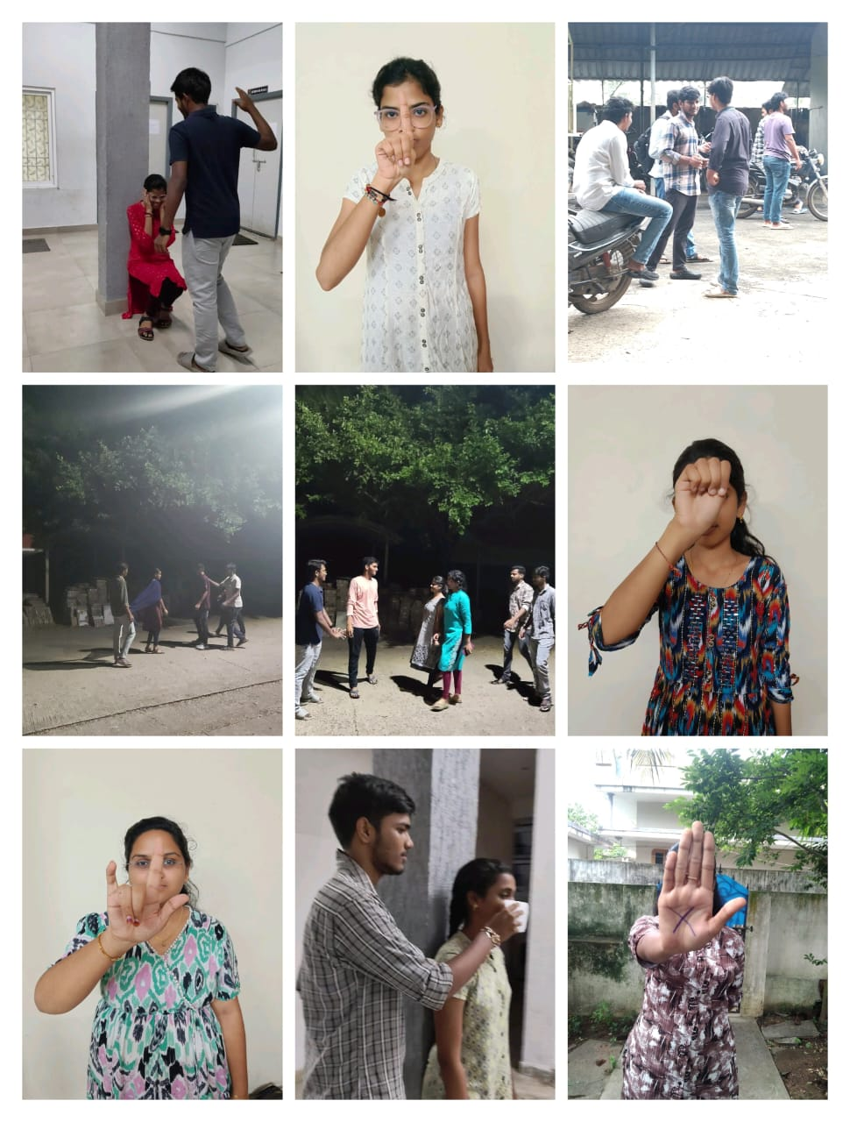
Fig. 1. Real Time dataset regarding the gesture analytics and women threat labels [9,15]

- Methodology
The research methodology used for this project was the generation of an all-inclusive real-time dataset to detect scenarios pertaining to women's safety [9]. First, the initial data set would be generated through capturing the original images by the use of several imaging devices [3]. These range from diverse situations and reflection of real-world settings that focus in categories critical to the safety of women [12]. Four key labels, "Alone Woman," "Men and Women," "Men Attacking Women," and "Help Gestures," were used because they were the main objectives of the study focused on real-time scenarios [7]. These were the main goals because detecting dangerous moments or calls for assistance were the two main questions to be investigated [5].

The size of the dataset should be enlarged with variability in order to have representations of different environmental conditions and situations [10]. As it is very difficult to get large-scale quantities of real-world images, deep learning techniques such as annotation and data augmentation were used [6]. Actually, annotation was the most important activity during which every object of the image was labeled in greater detail so that the generated dataset accurately represented the predefined categories [11]. This was an important step to further train the model; the object detection algorithm relies on the proper tagging between how intricate and overlapping visual patterns can be differentiated by it [8].
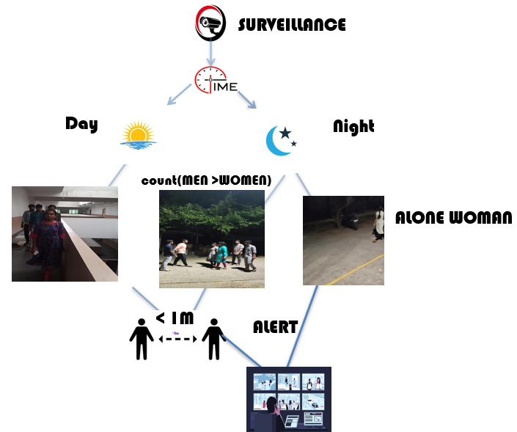
Fig. 2. Flow chart representing the entire process of women’s safety

After annotation, the augmentation techniques were employed, which increased the size of the created dataset without damaging the original images [4]. Augmentation is very important for improvement in the performance of a model because it introduces variability and diversity into the dataset [15]. Several augmentation techniques were employed, such as geometric transformation techniques including rotation, translation and scaling, but adjustments of brightness and flipping [2]. These transformations mimicked real-world conditions under which the model may be called upon to perform, including changing lighting conditions, camera angles, and points of view [7]. Augmentation increases the size of the dataset and its diversity, making it more likely to avoid over-fitting at some point and develop generalization capability [9].

Then, selecting appropriate object detection models is the next part of the research with the dataset in place [10]. The selected YOLOv8 model made this possible, which is in high accuracy and offers a great speed suitability for the tasks of real-time object detection [6,21,22,24]. YOLOv8 is noted for its ability to look at a single image and within a real-time detect several objects in it; hence its usage applies considerably for these study cases [12,22,24]. Moreover, with the nature of architecture, it is well-suited for computations over big data sets and real-time applications [14].
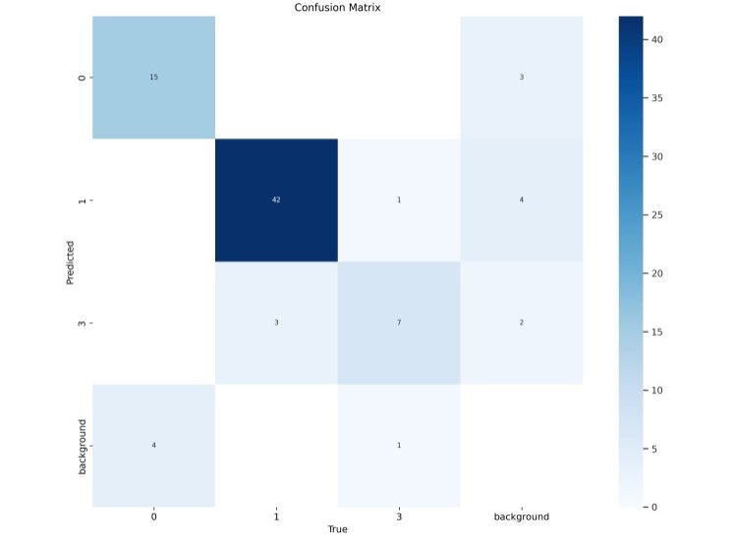
Fig. 3. Confusion Matrix representing the four labels

Then, a subset of the said dataset was divided into a training set and a testing set [1]. The majority of the dataset was employed in the training set, which would be fed into the network so that it could be trained to recognize and classify the objects according to the predefined labels [13]. On the other hand, the test set would be used to check the performance of the model once the training process was accomplished [5]. This is the norm in many machine learning implementations; it trains the model on one section of data but then evaluates on unseen data such that the model can generalize to new situations [8].

In essence, training the YOLOv8 model involved feeding the image augmented with an annotated image into the model where it processes the images and then learns patterns and features associated with each label [11,21,24]. The YOLOv8 architecture works based on cutting any given image into a grid and then predicting the class probabilities along with the bounding boxes for each grid cell [3,21]. Such processes underwent several loss functions that optimized the model which in turn helped improve the accuracy of its predictions over time [16]. Several epochs passed with training, which allowed a model to update and refine its understanding of the data and adjust the internal parameters in order to better detect and classify objects [7].

Periodically, while following the training curve, the model was evaluated with a number of metrics: precision, recall, and mean average precision (mAP), which apparently reflected every characteristic of the quality of the model [9]. Precision measures how accurate the model was with its positive predictions, recall determines the correctness of retrieving all pertinent objects, and mAP brings in an overall evaluation of the detection capability of the model [13]. Loss curves were also generated to monitor a model's ability across epochs of training [12]. These curves indicated how the accuracy and error rates of the model change over time, therefore allowing useful feedback in case adjustments to the training process were needed [14].

Next, after having completed the training phase, the model was evaluated on the test set [4]. In this context, it means that the model was run on unseen test data and its performance is analyzed based on the same metrics used during training [2]. The results were then graphed to explain the performance of the model with accuracy, loss, and detection capability [15]. Based on these representations, it was easy to tell how well the model had learned to detect objects and correctly classify scenarios related to women's safety [3,22]. All these graphs were further analyzed and made possible the assessment of areas where the model could be worked upon-to reduce false positives or increase speed of detection [6].

Finally, the trained model was deployed by using the platform Roboflow [13]. The said platform was designed to make easy deployment of machine learning models while working upon the basic computer vision tasks [11]. It has the features of model management, dataset organization, and deployment tools; hence, it is an excellent solution for real-time applications [9]. The YOLOv8 model was deployed through Roboflow, thereby making the model accessible to real-time inferences integrated into systems that require continuous monitoring and detection of threats [8,24].

The model was, during the process of its deployment, tested in the live environment to check how it would perform under real-world conditions [12]. It involved passing live video feeds into the model, which operates on real-time analysis of data to generate predictions based on labels specified [16,20]. The deployment stage was crucial in establishing the extent to which the model performed under real conditions where lighting, camera angles, and other features could be different from those conditions experienced in the training and test data [9]. Real-time evaluation has immensely provided precious feedback concerning the speed and accuracy that can lead to real-time monitoring of safety-related scenarios for women [6].

Therefore, the methodology was based on a robust data collection method with the latest advanced deep learning techniques and cutting-edge object detection models so that the system could be developed to detect women's safety threats in real-time [13]. Preparation of datasets with careful emphasis on augmentation and further training the YOLOv8 model established a highly accurate and efficient detection system, which was then deployed and gave a powerful tool for real-time monitoring and intervention [12,24].
- Modelling

Annotation
Annotation in object detection refers to labeling with bounded boxes and corresponding class labels for training. In object detection, bounding boxes are typically represented by four parameters
(x, y, w, h)
Where,
x, y - coordinates of center of box
w, h - coordinates of width and height

Or
(x_min, y_min, x_max, y_max):
Where
$x_{min },y_{min}$ - coordinates of the top-left corner
$x_{min },y_{min}$- coordinates of the bottom-right corner.
Label Encoding for YOLO Format:
YOLO models use a custom format for labeling, where bounding boxes are represented as normalized values between 0 and 1 relative to the image size.

Normalized(x,y,w,h):
$x_{norm}​=x / image width​$ ,$y_{norm}​=y / image height​$
$w_{norm}​=w / image width​$ ,$h_{norm}​=h / image height​$
  - Augmentation
Data augmentation is the process of applying transformations to training images to increase the diversity of the dataset. It helps the model generalize better and prevents overfitting. Common augmentation techniques in object detection include scaling, translation, rotation, flipping, cropping, and color adjustments.
  - Translation (Shifting)
Translation moves the bounding box along the x or y axis.
For a translation vector the updated bounding box is:
$x^{'}=x+tx$ $x'=x+t_{x}$​
$y'=y+ty$ $y'=y+t_{y}$​
  - Scaling​
Scaling adjusts the size of the object relative to the image size.
For a scaling factor sss, the bounding box is updated as
$$w'=s⋅w$$

$$h'=s⋅h$$
  - Rotation
Rotation transforms the image and the bounding boxes by rotating them by an angle θ\thetaθ. To rotate bounding boxes, you need to apply rotation matrices.

The new coordinates $(x',y')(x', y')(x',y')$ after a rotation by θ\thetaθ around the center of the image $(xc,yc)(x_c, y_c)(xc​,yc​)$ are given by:

$$x'=xc​+(x-xc​)cos(θ)-(y-yc​)sin(θ)$$
$$y'=yc​+(x-xc​)sin(θ)+(y-yc​)cos(θ)$$
  - Horizontal and Vertical Flipping
Flipping reverses the image along the horizontal or vertical axis.
For horizontal flipping:
$$x'=image width-x$$
For vertical flipping:
$$y'=image height-y$$
  - Brightness and Contrast Adjustment
Brightness and contrast adjustments change the pixel intensity values. These transformations don’t affect the bounding boxes but can make the model more robust to lighting variations.

Brightness: A new pixel value can be obtained by:

$$I'=I+ΔI$$

Where I is the original intensity, and ΔI is a brightness offset.

Contrast: Adjust contrast by multiplying the intensity:

$$I'=α⋅(I-I_mean)+I_mean$$

Where α is the contrast factor, and${ I}_{mean}$ ​ is the mean pixel value.
  - YOLOv8
    - Intersection over Union (IoU)
The IoU is a key metric used to evaluate the performance of object detection models. It compares the overlap between the predicted bounding box and the ground truth bounding box.

$$IoU=\frac{Area of Overlap}{Area of Union}$$

Where:
Area of Overlap = area common to both the predicted box and the ground truth box.
Area of Union = total area covered by both the predicted and ground truth boxes.

    - Confidence Score
YOLO models output a confidence score that reflects how confident the model is that a bounding box contains an
object and the accuracy of its class prediction.

$$Confidence Score=P(Object)×IUpred, truth$$

Where:
- P(Object) is the probability that the object is present.
- IoUpred, truth​ is the IoU between the predicted box and the ground truth.
    - Loss Function
The YOLOv8 loss function is composed of three components:

Localization Loss (Bounding Box Loss): Measures the error in the predicted box location and size (e.g., using IoU loss, GIoU, DIoU, or CIoU).

$$Localization Loss=∑IoU Loss$$

Confidence Loss: Measures the accuracy of predicting object presence.

$$Confidence Loss=∑((cpred-ctrue)^{2})$$

Classification Loss: Measures how well the model classifies objects into the correct categories.

$$Classification Loss=∑((p^-p)^{2})$$
    - Sigmoid Function for Confidence and Class Scores
YOLOv8 uses the sigmoid function to map predicted scores to a range between 0 and 1 for both confidence and class probability predictions:

$$σ(x)=\frac{1}{1+e^{-x}}$$

This ensures that the output confidence score and class probabilities are between 0 and 1.
    - Softmax Function for Classification
For multi-class classification, YOLOv8 may use the softmax function to output class probabilities:
$$Softmax(zi​)=\frac{e^{z_{i}}}{Σ_{j}e^{z_{j}}}​​$$

Where:
$z_{i}$​ is the output score for class i.
    - Precision, Recall, and mAP (mean Average Precision)
- Precision: Measures the proportion of correct positive detections out of all detections.

$$Precision=\frac{True Positives}{True Positives+False Positives}​$$

- Recall: Measures the proportion of true positive detections out of all relevant detections.

$$Recall=\frac{True Positives}{True Positives + False Negatives}$$

mAP (mean Average Precision): Evaluates the precision and recall across different IoU thresholds (e.g., 0.5, 0.75, etc.).
    - Focal Loss (Optional)
For models dealing with class imbalance, focal loss can be used to penalize easy negatives and focus more on hard examples:

$$Focal Loss=-α_t (1-p_t )^γ log⁡(p_t)$$

Where:
- $p_{t}$​ is the model's estimated probability.
- $α_{t}$​ is the weighting factor.
- γ is the focusing parameter.
- Evaluation Metrices
Key performance metrics used to evaluate the model were accuracy, precision, recall, and F1-score. Accuracy is a measure of how often the model correctly predicts all scenarios being detected, while precision measures the proportion of actual positives, like detection of "men attacking women" compared to the total number of detections as positives. Recall evaluated how well a model would capture all the relevant instances of a specific label without missing any critical events. It gave an F1-score which presents a balanced measure of both precision and recall, especially useful in situations where failing to report something important, such as a dangerous situation, could be critical. The confusion matrices were also used to visualize how well the model can distinguish between different labels. This would be in conjunction with the analysis of loss curves in tracking the model's convergence during training for when the model would be ready for deployment. These metrics were preeminent for fine-tuning the model toward real-time deployment into scenarios that require accurate responses.
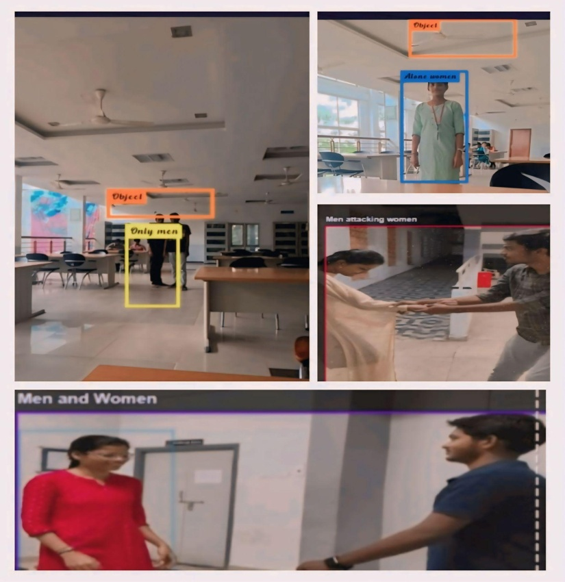
Fig. 4. Model Identifying the Labels
- Results
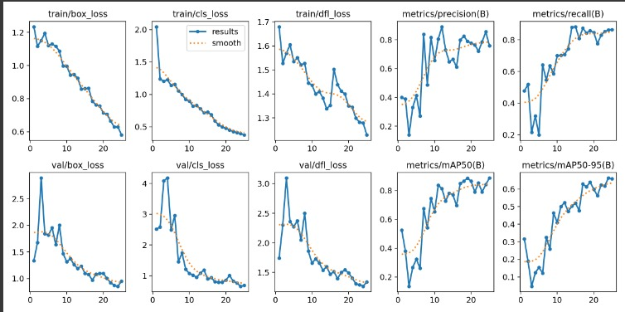
Fig. 5. Graph showing the Change in Training and Validation Accuracy across Epochs

Table 1. Performance of the Model

Class | Images | Instances | Box(P) | R | mAP50 | mAP50-95
All | 66 | 78 | 0.83 | 0.736 | 0.865 | 0.606
Lone Women | 66 | 20 | 0.986 | 0.65 | 0.873 | 0.615
Women Surrounded by Men | 66 | 46 | 0.846 | 0.891 | 0.94 | 0.71
Women Attacked by Men | 66 | 12 | 0.658 | 0.667 | 0.78 | 0.495

- Future Scope
The future of the Women’s Safety Warriors project has many exciting possibilities. First, it can be connected to smart city systems, using existing cameras and devices to improve safety in urban areas. The project can also develop new features, like recognizing faces and analyzing behavior, to better identify threats. A mobile app could be created, allowing women to send emergency alerts and receive safety updates in real time. Engaging the community is important, so creating a platform for feedback can help improve the system based on what users need. Working with local police can ensure quick responses to alerts, making the system more effective. Continuous research will help improve the technology, making it more accurate in different situations. The project can also expand globally, adapting to the unique safety concerns of various regions. Educational programs can teach women how to use the technology and raise awareness about safety issues. It’s essential to address privacy concerns and ensure the technology is used ethically. Finally, the project can explore eco-friendly practices to support sustainability goals. Overall, these developments can greatly enhance women’s safety and empowerment in society, making the world a safer place for everyone.
- Conclusion
In conclusion, this research highlights the importance of using deep learning technologies to improve women's safety in various environments. By developing a real-time detection system, we can identify potential threats and help women in distress. The study focused on creating a dataset that includes different scenarios, such as women being alone, interactions between men and women, and gestures that signal for help. These categories are crucial for understanding and responding to dangerous situations.
The use of the YOLOv8 model has shown promising results in accurately detecting these scenarios. The evaluation metrics, including accuracy, precision, and recall, indicate that the model can effectively recognize threats and provide timely alerts. This technology not only empowers women by enhancing their safety but also raises awareness about the issues they face in society.
Moreover, it is essential to address ethical concerns related to privacy and the responsible use of technology. Educational programs can play a vital role in teaching women how to use these tools effectively, ensuring they feel secure and supported. By combining technology with community awareness, we can create a safer environment for women everywhere.
Overall, this research contributes to the ongoing efforts to combat violence against women and emphasizes the need for innovative solutions that prioritize their safety and well-being. Future work should continue to refine these technologies and explore new ways to integrate them into everyday life, making the world a safer place for everyone.

References
- Kanjalkar, Jyoti, et al. "Smart Women Safety Solution with Alert System Using Machine Learning Approach." International Conference on Machine Learning, Deep Learning and Computational Intelligence for Wireless Communication. Cham: Springer Nature Switzerland, 2023.
- Lou, Haitong, et al. "DC-YOLOv8: small-size object detection algorithm based on camera sensor." Electronics 12.10 (2023): 2323.
- de Araujo Zeni, Luis Felipe, and Claudio Rosito Jung. "Real-time gender detection in the wild using deep neural networks." 2018 31st SIBGRAPI Conference on Graphics, Patterns and Images (SIBGRAPI). IEEE, 2018.
- Mujahid, Abdullah, et al. "Real-time hand gesture recognition based on deep learning YOLOv3 model." Applied Sciences 11.9 (2021): 4164.
- DPaul, M. T., M. Kalaiselvi, and M. Nagarathinam. "Experimental analysis of women safety management system by using iot enabled machine learning strategies." Turkish Journal of Physiotherapy and Rehabilitation 32.2 (2020): 934-941.[7] Kvalseth, T.O., Cautionary Note about R2.
- Sahay, Kishan Bhushan, et al. "A real time crime scene intelligent video surveillance system in violence detection framework using deep learning techniques." Computers and Electrical Engineering 103 (2022): 108319.
- Monalisha, K., and T. S. Kirthana. "IoT based safety system for women." 2021 6th International Conference on Communication and Electronics Systems (ICCES). IEEE, 2021.
- Carneiro, Gustavo, et al. "Supervised learning of semantic classes for image annotation and retrieval." IEEE transactions on pattern analysis and machine intelligence 29.3 (2007): 394-410.
- Shorten, Connor, and Taghi M. Khoshgoftaar. "A survey on image data augmentation for deep learning." Journal of big data 6.1 (2019): 1-48
- Fleming, Paul J., etal."Men's violence against women and men are inter-related: Recommendations for simultaneous intervention." Social science & medicine 146 (2015): 249-256.
- Cardoso, Lauren F., et al. "Recent and emerging technologies: Implications for women's safety." Technology in Society 58 (2019): 101108.
- Ansari, Mohd Ali, and Dushyant Kumar Singh. "Review of deep learning techniques for object detection and classification." Communication, Networks and Computing: First International Conference, CNC 2018, Gwalior, India, March 22-24, 2018, Revised Selected Papers 1. Springer Singapore, 2019.
- Navarrete-Hernandez, Pablo, Arielle Vetro, and Paz Concha. "Building safer public spaces: Exploring gender difference in the perception of safety in public space through urban design interventions." Landscape and Urban Planning 214 (2021): 104180.
- Meijer, Albert, and Martijn Wessels. "Predictive policing: Review of benefits and drawbacks." International Journal of Public Administration (2019).
- Wen, Yu, et al. "Designed for safety: characteristics and trends in crime prevention through environmental design research." Journal of Asian Architecture and Building Engineering (2024): 1-19.
- Ahmed, Imran, et al. "A deep learning-based social distance monitoring framework for COVID-19." Sustainable cities and society 65 (2021): 102571.Association Spring Conference, May 5, 2000.
- Sathyasri, B., et al. "Design and implementation of women safety system based on Iot technology." International Journal of Recent Technology and Engineering (IJRTE) 7.6S3 (2019): 177-181.
- Ullah, Fath U. Min, et al. "A comprehensive review on vision-based violence detection in surveillance videos." ACM Computing Surveys 55.10 (2023): 1-44.
- Bello, Oluwabusayo Adijat, and Komolafe Olufemi. "Artificial intelligence in fraud prevention: Exploring techniques and applications, challenges and opportunities." Computer Science & IT Research Journal 5.6 (2024): 1505-1520.
- Srinivas Rao, K. , Divakara Rao, D. V. , Patel, I. , Saikumar, K. and Vijendra Babu, D. (2023). Automatic Prediction and Identification of Smart Women Safety Wearable Device Using Dc-RFO-IoT. Journal of Information Technology Management, 15(Special Issue), 34-51. doi: 10.22059/jitm.2022.89410.
- M. Pulipalupula, S. Patlola, M. Nayaki, M. Yadlapati, J. Das and B. R. Sanjeeva Reddy, "Object Detection using You Only Look Once (YOLO) Algorithm in Convolution Neural Network (CNN)," 2023 IEEE 8th International Conference for Convergence in Technology (I2CT), Lonavla, India, 2023, pp. 1-4, doi: 10.1109/I2CT57861.2023.10126213.
- Matta, V. D., Mudunuri, K. V. R. R., Sai Baba, B. C. S., Kiran, K. B., Veenadhari, C. L., & Prasanthi, B. V. (2023, August). Single Use Plastic Bottle Recognition and Classification Using Yolo V5 and V8 Architectures.
- A. Sahithi, B. S. Teja, C. V. Shastry, C. Venugopal and C. Rajyalakshmi, "Enhancing Object Detection and Tracking from Surveillance Video Camera Using YOLOv8," 2023 International Conference on Recent Advances in Information Technology for Sustainable Development (ICRAIS), Manipal, India, 2023, pp. 228-233, doi: 10.1109/ICRAIS59684.2023.10367122.
- Matta, V. D., Mudunuri, K. V. R. R., Sai Baba, B. C. S., Kiran, K. B., Veenadhari, C. L., & Prasanthi, B. V. (2023, August). Single Use Plastic Bottle Recognition and Classification Using Yolo V5 and V8 Architectures. In International Conference on Cognitive Computing and Cyber Physical Systems (pp. 99-106). Cham: Springer Nature Switzerland.

